ORDINANCE NO. 2024-35
CPA 23-09

RE-ADOPTION OF AN ORDINANCE OF THE CITY OF NEWBERRY, FLORIDA, AMENDING ORDINANCE NO. 4-91, RELATING TO AN AMENDMENT TO THE FUTURE LAND USE PLAN MAP EXPANDING THE BOUNDARY OF THE URBAN SERVICE AREA, FUTURE LAND USE ELEMENT, AND RELATED SUB ELEMENTS, IN ACCORDANCE WITH SECTIONS 163.3161 THROUGH 163.3215, FLORIDA STATUTES; PROVIDING FOR AMENDMENT TO THE LAND USE PLAN; PROVIDING SEVERABILITY; REPEALING ALL ORDINANCES IN CONFLICT; AND PROVIDING AN EFFECTIVE DATE.

WHEREAS, Section 166.021, Florida Statutes, empowers the City Commission of the City of Newberry, Florida, hereinafter referred to as the City Commission, to prepare, adopt and implement a Comprehensive Plan;

WHEREAS, Sections 163.3161 through 163.3215, Florida Statutes, the Local
Government Comprehensive Planning and Land Development Regulation Act, empowers and requires the City Commission to prepare, adopt and implement a Comprehensive Plan;

WHEREAS, an application, CPA 23-09, for an amendment for lands described in Exhibit “A” attached hereto, to the Future Land Use Plan Map of the City of Newberry Comprehensive Plan, hereinafter referred to as the City's Comprehensive Plan has been filed with the City;

WHEREAS, the Planning and Zoning Board of the City of Newberry, Florida, hereinafter referred to as the Planning and Zoning Board, has been designated as the City of Newberry Local Planning Agency, hereinafter referred to as the Local Planning Agency;

WHEREAS, pursuant to Section 163.3174, Florida Statutes, and Ordinance No. 9-92, as amended, entitled City of Newberry Land Development Regulations, hereinafter referred to as the City's Land Development Regulations, the Planning and Zoning Board, serving also as the Local Planning Agency, held the required public hearing, with public notice having been provided, on said application for an amendment, as described below, to the Future Land Use Plan Map, Future Land Use Element, and Urban Service Area boundary of the City's Comprehensive Plan, and, at said public hearing, the Planning and Zoning Board, serving also as the Local Planning Agency, reviewed and considered all comments received during said public hearing concerning said application for an amendment, as described below, to the Future Land Use Plan Map of the City's Comprehensive Plan and recommended to the City Commission approval of said application for amendment, as described below, to the Future Land Use Plan Map of the City's Comprehensive Plan;

WHEREAS, the City Commission held two public hearings, with public notice having been provided, under the provisions of the regular amendment public hearing procedures established in Sections 163.3161 to 163.3215, Florida Statutes, on said application for amendment, as described below, to the Future Land Use Plan Map of the City's Comprehensive Plan and at said public hearings, the City Commission reviewed and considered all comments received during said public hearings, including the recommendation of the Planning and Zoning Board, serving also as the Local Planning Agency;

WHEREAS, the City Commission found said application for an amendment, as described below, to the Future Land Use Plan Map, Future Land Use Element, and Urban Service Area boundary of the City’s Comprehensive Plan to be compatible with the Land Use Element objectives and policies, and those of other affected elements of the City’s Comprehensive Plan and authorized transmittal to the Florida Department of Commerce, hereinafter “FDOC”;

WHEREAS, the proposed large-scale land use amendment was received by the FDOC, assigned File No. 23-03ESR, was reviewed and found to not have adverse impacts on State of Florida resources;

WHERAS, the City Commission held an adoption hearing on December 11, 2023, and transmitted the adopted Ordinance 2023-21 to FDOC on April 3, 2024;

WHEREAS, pursuant to Section 163.3184(3)(c)2., Florida Statutes as amended, the City was unable to transmit the land use plan amendment to FDOC within the 10 working days allotted to local governments;

WHEREAS, the City has requested from and been granted an extension by FDOC to comply with Section 163.3184 by October 31, 2024;

WHEREAS, the City Commission, found, subsequent to the expedited submittal to the Florida Department of Economic Opportunity pursuant to the Expedited State Review Process provided in Section 163.3184 (3), Florida Statutes, no objections recommendations or comments were submitted by said Department and that said application for an amendment, as described below, to the Future Land Use Plan Map, Future Land Use Element, and Urban Service Area boundary of the City’s Comprehensive Plan to be found by the State Land Planning Agency to be compatible with the other affected elements of the City’s Comprehensive Plan; and

WHEREAS, the City Commission, has determined and found that approval of an application for amendment to the Future Land Use Plan Map, Future Land Use Element, and Urban Service Area boundary of the City’s Comprehensive Plan would promote the public health, safety, morals, order, comfort, convenience, appearance, prosperity or general welfare.

NOW, THEREFORE, BE IT ORDAINED BY THE PEOPLE OF THE CITY OF NEWBERRY, FLORIDA, AS FOLLOWS:

Section 1. Pursuant to an application, CPA 23-09 by the City Commission, to amend the Future Land Use Plan Map, the Urban Services Area Sub Element of the Future Land Use Element, and Urban Services Area boundary of the City's Comprehensive Plan as adopted in by amending the text of the Future Land Use Element to reflect the current community vision for the City’s development and redevelopment efforts, amending the text of the Future Land Use Element and the Future Land Use Plan Map, and amending the Urban Services Area boundary. Also included are technical changes resulting from urban services area policy clarification, and changes to FS 163.3177. The amended article of the City of Newberry Comprehensive Plan is attached hereto as Attachment “A,” the amended Urban Services Area boundary of the Future Land Use Map is attached hereto as Attachment “B,” and made a part hereof.
Section 2. Transmittal. The City Manager or their designee is directed to transmit a copy of this Ordinance to the FDOC within 10 days from the date of re-adoption as required under the Large-Scale amendment process provided in Fs. 163.3184, as amended.

Section 3. Severability. If any provision or portion of this Ordinance is declared by any court of competent jurisdiction to be void, unconstitutional or unenforceable, then all remaining provisions and portions of this Ordinance shall remain in full force and effect.

Section 4. Conflict. All ordinances or parts of ordinances in conflict herewith are, to the extent of such conflict, hereby repealed.

Section 5. Effective Date. This ordinance shall become effective upon adoption. The effective date of this plan amendment shall be the date a final order is issued by the FDOC or Administration Commission finding the amendment in compliance in accordance with Section 163.3184, Florida Statutes, whichever occurs earlier. No development orders, development permits or land uses dependent on this amendment may be issued or commence before it has become effective. If a final order of noncompliance is issued, this amendment may nevertheless be made effective by adoption of a resolution affirming its effective status, a copy of which resolution shall be sent to the Department of Economic Opportunity, Division of Community Planning and Development, 107 East Madison Street, MSC-160, Tallahassee, FL 32399-4120.

Section 6. Authority. This Ordinance is adopted pursuant to the authority granted by Section 166.021 and Sections 163.3161 through 163.3215, Florida Statutes.

DONE, THE FIRST READING, by the City Commission of the City of Newberry, Florida, at a regular meeting the 14th day of October, 2024.

[REMAINDER OF THIS PAGE INTENTIONALLY LEFT BLANK.]

DONE, THE PUBLIC NOTICE, in a newspaper of general circulation in the City of Newberry, Florida, by the City Clerk of the City of Newberry, Florida on the 10th day of October, 2024.

DONE THE SECOND READING, AND ADOPTED ON FINAL PASSAGE, by an affirmative vote of a majority of a quorum present of the City Commission of the City of Newberry, Florida, at a regular meeting, this 28th day of October, 2024.

BY THE MAYOR OF THE CITY OF NEWBERRY, FLORIDA

____________________________________ Honorable Jordan Marlowe, Mayor

ATTEST, BY THE CLERK OF THE
CITY COMMISSION OF THE CITY OF
NEWBERRY, FLORIDA:

____________________________
Judy S. Rice, City Clerk

APPROVED AS TO FORM AND LEGALITY:

____________________________
City Attorney’s Office

EXHIBIT “A”
PROPOSED URBAN SERVICE AREA BOUNDARY

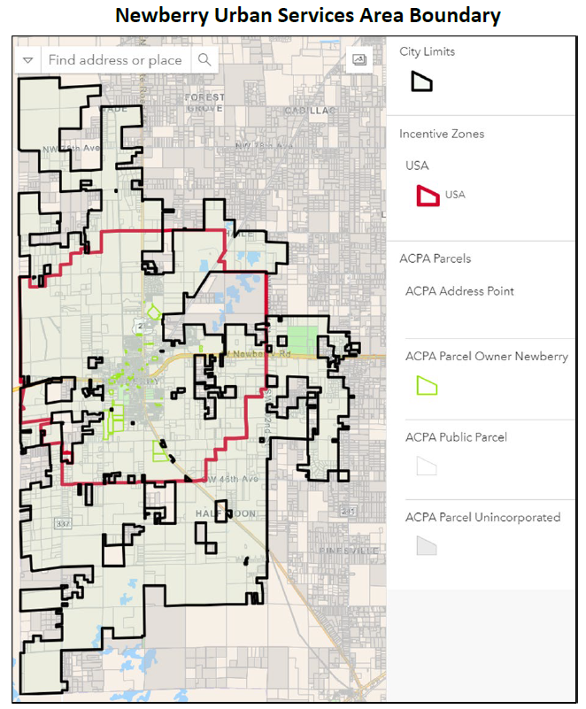

EXHIBIT “A” CONTINUED

FUTURE LAND USE ELEMENT TEXT

