**ORDINANCE NO. 2025-05**

LDR 25-01

**AN ORDINANCE OF THE CITY OF NEWBERRY, FLORIDA, AMENDING THE TEXT OF THE CITY OF NEWBERRY LAND DEVELOPMENT REGULATIONS, AS AMENDED; TO AMENDING APPENDIX B, THE LAND DEVELOPMENT REGULATIONS, SPECIFICALLY, ARTICLE 2, SECTION 2.1, ARTICLE 4, SECTIONS 4.2, 4.10 THROUGH 4.15 AND 4.22, ALL RELATING TO ESTABLISHMENT OF DEVELOPMENT STANDARDS FOR LARGE-SCALE RETAIL ESTABLISHMENTS, AS DEFINED HEREIN; PROVIDING SEVERABILITY; REPEALING ALL ORDINANCES IN CONFLICT; PROVIDING FOR CODIFICATION; AND PROVIDING AN EFFECTIVE DATE**

**WHEREAS,** Section 166.021, Florida Statutes, as amended, empowers the City Commission of the City of Newberry, Florida, hereinafter referred to as the City Commission, to prepare, adopt and enforce land development regulations;

**WHEREAS**, City Commission of the City of Newberry (“City”) desires a diverse and competitive market through minimization of potential socioeconomic impacts unique to large-scale retail establishments greater than 80,000 square feet on small towns and small businesses, and wishes to adopt regulations which would minimize the potential negative impacts on public interest;

**WHEREAS**, at the June 10, 2024 at the regular meeting of the City Commission, the City adopted a zoning-in-progress ordinance (Ordinance 2024-15) establishing a stay on all large-scale retail establishment applications for a period of 6 months with automatic renewal for an additional 6 months and expiring June 10, 2025;

**WHEREAS,** on August 26, 2024, Commission meeting, the staff presented peer study analyzing large scale retail development in other local communities;

**WHEREAS**, the City has adopted “Gateway Overlay Standards” along the two state roads bisecting the City, State Road 26 and State Road 45 that provide design standards for new development;

**WHEREAS**, these standards shall be revised to also consider the potential impacts of large-scale retail establishments;

**WHEREAS**, these standards for the purposes of the building design of large-scale retail establishments shall be applicable outside of the “Gateway Overlay District”;

**WHEREAS**, pursuant to Section 163.3174, Florida Statutes, as amended, and the City of Newberry Land Development Regulations, the Planning and Zoning Board, serving also as the Local Planning Agency, held the required public hearing, with public notice having been provided, on said application for a text amendment, as described below, and at said public hearing, the Planning and Zoning Board, serving also as the Local Planning Agency, reviewed and considered all comments received during said public hearing concerning said application for a text amendment, as described below, and recommended to the City Commission approval of said application for an amendment, as described below;

**WHEREAS**, pursuant to Section 166.041, Florida Statutes, as amended, the City Commission held the required public hearings, with public notice having been provided, on said application for a text amendment, as described below, and at said public hearings, the City Commission reviewed and considered all comments received during said public hearings, including the recommendation of the Planning and Zoning Board, serving also as the Local Planning Agency, concerning said application for an amendment, as described below; and

**WHEREAS**, the City Commission, has determined and found that a need and justification exists for the approval of said application for amendment, as described below;

**WHEREAS**, the City Commission, has determined and found that approval of said application for an amendment, as described below, is consistent with purposes and objectives of the comprehensive planning program and the Comprehensive Plan;

**WHEREAS**, the City Commission has determined and found that approval of said application for a text amendment, as described below, will further the purposes of the Land Development Regulations and other ordinances, regulations and actions designed to implement the Comprehensive Plan; and

**WHEREAS**, the City Commission has determined and found that approval of said application for a text amendment, as described below, would promote the public health, safety, morals, order, comfort, convenience, appearance, prosperity or general welfare.

**NOW, THEREFORE, BE IT ORDAINED BY THE CITY COMMISSION OF THE CITY OF NEWBERRY, FLORIDA, AS FOLLOWS:**

**Section 1**. Pursuant to File No. LDR 25-01, the City of Newberry, a Florida municipal corporation, hereby amends the text of the Land Development Regulations as follows:

**Section 2.1. Definitions, general.**

For the purpose of these Land Development Regulations, certain terms or words used herein shall be interpreted as follows:

The word "person" includes a firm, association, organization, partnership, trust, company, or corporation as well as an individual.

The present tense includes the future tense, the singular number includes the plural, and the plural number includes the singular.

The word "shall" is mandatory, the word "may" is permissive.

The words "used" or "occupied" include the words "intended, designed, or arranged to be used or occupied."

The word "lot" includes the words "plot," "parcel," "tract," or "site."

The word "structure" includes the word "building" as well as other things constructed or erected on the ground, attached to something having location on the ground, or requiring construction or erection on the ground. Among other things, structures include walls, buildings, fences, signs, and swimming pools.

The word "land" includes the words "water," "marsh," or "swamp."

The word "abut" shall not include directly across from.

The words "city commission" mean the City Commission of Newberry, Florida.

The word "city" means City of Newberry, Florida.

* * *

*Large-Scale Retail*. Establishment shall mean a single building that occupies 60,000 square feet of gross floor area or greater and serves a regional market. Large-scale retailers include, but are not limited to, membership wholesale clubs that emphasize bulk sales, and discount, home improvement, sports equipment, furniture, farm and department stores. Retail uses that do not meet these criteria are classified as retail sales, unless otherwise noted in this code. The square footage, trip generation rate and the use for the purposes of this Section shall not include ancillary service and self-service stations or out parcel developments.

* * *

**Section 4.2. Supplementary district regulations.**

4.2.1. *Scope.* Provisions set forth in this section apply to all areas subject to these Land Development Regulations, and all zoning districts therein, unless exceptions are specifically provided relating to one or more zoning districts, or except as otherwise provided in these Land Development Regulations.

* * *

4.2.36. *~~Architectural site and design standards~~*Reserved.

~~4.2.36.1.~~ *~~Applicability.~~* ~~The planning and zoning board, board of adjustment, city commission and city staff shall use these standards in enforcing the provisions of the City's Land Development Regulations. These standards are intended to apply to all new construction and reconstruction of multiple-family residential commercial and industrial developments within the City of Newberry, Florida.~~

~~4.2.36.2.~~ *~~Statement of philosophy.~~* ~~This section establishes architectural standards for new construction and the adaptive reuse, alteration, expansion or modification of multiple-family residential, commercial and industrial development within the City of Newberry, Florida in a manner that fosters the best match between the needs of human users and the architectural heritage and character of the city. The resultant building plans should reflect a comprehensive proposal integrating lighting, planting, parking and site amenities such as fountains, sculpture and street furniture. Screening of utilities and services should be incorporated. Sensitivity to development demands, vehicular and pedestrian traffic patterns, and the needs of residents and merchants have been considered in the development of these standards.~~

~~4.2.36.3.~~ *~~Statement of purpose.~~* ~~The purposes of these architectural standards are:~~

~~1. To provide design standards for the development of building plans for multiple-family residential, commercial and industrial development to minimize decisions based on individual tastes and preferences in the review and approval of plans.~~

~~2. To establish clear and easily understood design criteria to guide property owners and their architects in the appropriate design of new construction and building alterations.~~

~~3. To promote a cohesive image of the community as a whole, while allowing for architectural innovation. It is not the intent of these standards to limit new construction or building alterations to one particular architectural style, but to create and enhance the aesthetic features of the community.~~

~~4.2.36.3.1.~~ *~~Relation to Municipal Code.~~* ~~This document is intended to provide standards for the administration of site and development approvals as provided within the Land Development Regulations for multiple-family residential, commercial and industrial developments.~~

~~4.2.36.4.~~ *~~Standards for new construction and re-construction for commercial (non-industrial) development.~~*

~~Architectural style and design quality; form and mass this section illustrates appropriate architectural style and form and mass for all new construction and re-construction of multiple family and non-industrial commercial development.~~

~~Designs shall be required that respect, reflect, reference, adapt and interpret the local commercial, industrial and governmental architectural styles of the late 1800's and early 1900's and design themes found in Alachua County and contiguous counties.~~

~~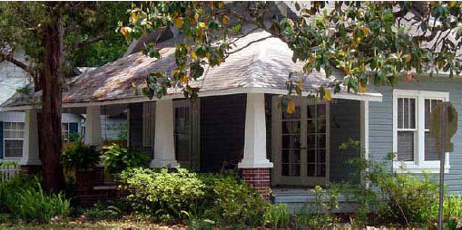~~

~~These elements and themes in commercial architecture include vertical thrust, symmetrical lines, proportioned masonry and balance.~~

~~Elements and themes in residential architecture consist of gabled roofs, porches with supporting pillars and light (not heavy) structures.~~

~~Details that are appropriate in commercial districts are overhangs, peaked roof forms, cornices, arches, lintels and pilasters.~~

~~Design details that are consistent with the overall style and proportion of the building design shall be encouraged. Buildings shall be generally oriented with varying setbacks to provide visual interest and varying shadow patterns.~~

~~Adjacent residential and nonresidential uses shall be separated as is necessary to maintain a livable residential environment. This may be achieved with masonry walls, landscaping, berms, building orientation and activity limitation.~~

~~1.~~ *~~Building orientation and placement on-site.~~*

~~Buildings shall be oriented to the street respecting both pedestrian and automobile traffic, with front and rear access where possible. No building shall turn its back on an adjacent use. New building shall have double facades, where appropriate.~~

~~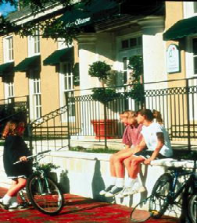~~

~~Facades visible to the public shall be attractive and articulated as follows:~~

~~a.~~ *~~Design components:~~* ~~Uninterrupted facade length shall not exceed 30 feet (100 feet for buildings exceeding 15,000 square feet). Interruptions shall include wall plane projections/recesses of minimum six inches (five feet for buildings in excess of 15,000 square feet) and one or more pilasters, columns, canopies/porticos, arcades/colonnades and parapets.~~

~~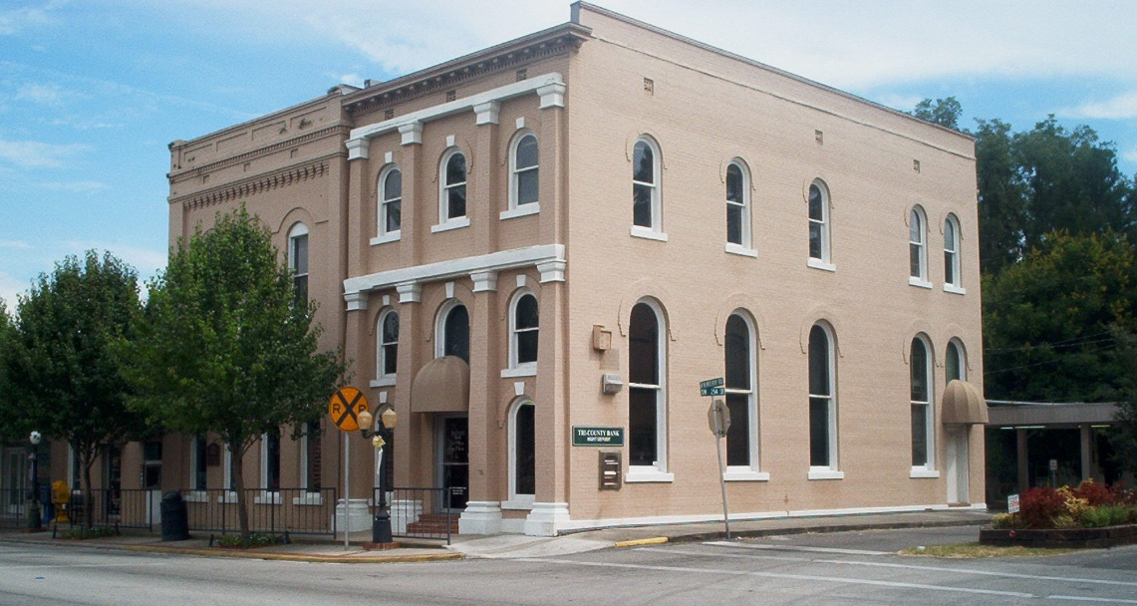~~

~~b.~~ *~~Detail features:~~* ~~Patterns shall repeat at intervals of maximum 30 feet horizontally and vertically to include windows, color/texture/material changes, surface modeling changes such as offsets, reveals or ribs minimum width 12 inches and one inch deep.~~

~~(1) In the Main Street/Historic District as defined in the Comprehensive Plan, new buildings or additions to existing buildings shall be brought to the right-of-way to encourage a store front appearance and promote walkability within the neighborhood.~~

~~(2) Along U.S. 27/41 and within the areas outside the Main Street/Historic District as defined in the Comprehensive Plan, new buildings or additions to existing buildings may be set back from the right-of-way. If parking is located in the front yard area, then the lot shall be screened with opaque landscaping or buffers to hide the parking area from the adjacent street.~~

~~(3) Buildings shall be located in a manner that respect and relate to the siting of surrounding structures.~~

~~(4) Where buildings are permitted to be setback from the street, but no parking is provided in the front yard, front lawns should be provided and maintained as within districts where front yards are traditional.~~

~~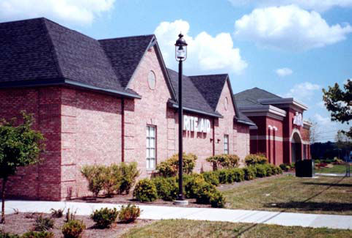~~

~~2.~~ *~~Parking requirements.~~* ~~Parking areas for shared or community use should be encouraged.~~

~~a. Parking lots should be located at the rear or side of a building (except where permitted in front yard area). If located at the side, screening shall be provided in the following landscape buffering requirements.~~

~~b. A parking lot or garage may not be adjacent to or opposite a street intersection. Adjacent on-street parking may apply toward the minimum parking requirements.~~

~~3.~~ *~~Landscaped buffers.~~*

~~a. Promote the use of shrubs, trees and other plants to provide a smooth, flowing transition between buildings and/or land uses is best. The use of native plants and existing vegetation is also encouraged.~~

~~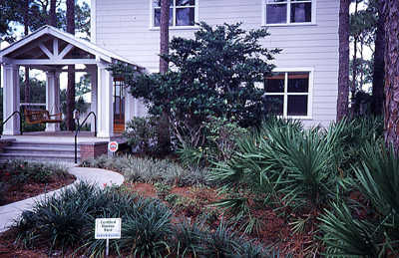~~

~~b. Overall composition and location of landscaping shall complement the scale of the development and its surroundings. In general, larger, well placed contiguous planting areas shall be preferred to smaller, disconnected areas.~~

~~c. Property line landscaping. Along property lines abutting nonresidential development, or vacant property zoned for same, in addition to buffering requirements of this Code there shall be landscaped screens to complement the project consisting of plantings at least three feet in height, unless otherwise specified.~~

~~d. Required landscaped screening shall be at least 50 percent opaque throughout the year. Required screening may be satisfied by one or some combination of: A decorative fence not less than 50 percent opaque behind a continuous landscaped area or a masonry wall.~~

~~e. Foundation landscaping. Along 50 percent of each facade length of the building there shall be planted a five-foot wide landscaped area between the parking area and building.~~

~~f. Buffer yards. Along collector and arterial roadways there shall be a 15-foot wide landscaped area (30 feet wide of projects containing buildings of 15,000 square feet or larger). These buffer plantings shall meet the opaque requirements of required landscape screening.~~

~~g. Parking areas. As specified in the off-street parking requirements of this Code and in addition: (1) all parking and loading areas fronting public streets or sidewalks and all parking and loading areas abutting residential districts or uses shall provide a landscaped area at least five feet wide along the public street or sidewalk; screening at least three feet in height and not less than 50 percent opaque; and one tree for each 25 linear feet of parking lot fringe; and (2) parking area interior landscaping; the corners of parking lots, islands and all other areas not used for parking or vehicular circulation shall be landscaped. Vegetation can include turf grass, native grasses or other perennial flowering plants, vine, shrubs or trees. Such spaces may include architectural features such as benches, kiosks or bicycle parking.~~

~~h. Drainage retention areas. Adjacent to public right-of-way/access drives there shall be the same buffer required above for required landscape screening.~~

~~i. Street trees. A minimum of one deciduous canopy tree per 40 feet of street frontage, or fraction thereof, shall be required. Trees can be clustered and do not need to be evenly spaced. Trees should preferably be located between the sidewalk and the curb, within the landscaped area of a boulevard, or in tree wells installed in pavement or concrete. If placement of street trees within the right-of-way will interfere with utility lines, trees may be planted within the front yard setback adjacent to the sidewalk.~~

~~4. A Florida Vernacular architectural style for each structure is required. This shall include the following architectural elevations facing public rights-of-way:~~

~~a. A metal panel five-seam or metal shake roof is acceptable. A five-tab 25-year dimensional shingle roof or manufactured equivalent of a wood shake roof is acceptable. Three-tab shingles, barrel vaulted tiles or corrugated roof systems are not permissible.~~

~~b. Pitch of main roof, hipped or gable, shall be no greater than 5:12; mansard roof shall be no greater than 9:12; porch roof shall be a lower pitch than the main roof. A minimum six-foot overhang is required for any roof structure. All structures must have a minimum 3:12 slope roof. Multiple roof systems with matching roof slopes are permissible. Low slopes ("Flat") roof systems are permissible when screened by a mansard roof or parapet wall meeting the design requirements.~~

~~c. The predominant exterior color shall be consistent with the historic palates of North Florida. These include but are not limited to pastel shades, white; earth tones and brick.~~

~~d. Manufactured brick or materials that have the appearance of brick are acceptable. Horizontally struck stucco, exterior insulated finish system stucco panels, board and batten, wood or vinyl siding, and stained hardwood panels shall also be considered acceptable finishes.~~

~~e. Front porch. The front porch must encompass an area greater than 50 percent of the front facade. The porch must be a minimum of 60 inches in depth.~~

~~f. Gingerbread trim and/or porch railings, columns or posts shall have the appearance of light frame wood construction.~~

~~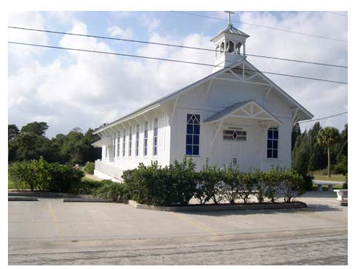~~

~~g. Trim shall be considered railings, columns, door and window surrounds, soffits, shutters, gutters and downspouts, and other decorative elements. Trim finishes shall be of a contrasting compatible color to the primary building color.~~

~~h. There shall exist no area greater than 400 square feet of contiguous blank wall area on any front facade that remains unadorned by architectural features that include, but are not limited to, windows, doors, lights, banding trim or porch elements.~~

~~i. There shall not exist any singular facade that has greater than 100 lineal feet of run without a minimum 16-inch break, by using a directional or material change.~~

~~j. Metal-clad structures are permissible. Internal bracing must be certified to accept additional finishes or structures applied to the exterior metal panels. No external "X" bracing is to be visible on any front facade. Finish panels must be able to accept a painted finish. All exterior wall finishes must match the primary building color. The use of corrugated, synthetic or fiberglass panels is prohibited on any front wall or any front roof surface. All design requirements must be met for metal-clad structures as for any other new structure.~~

~~k. The predominant exterior color shall be applied to all sides of the structure.~~

~~l. The design requirements listed in (a) above shall be applicable to all new construction in the commercial districts prescribed, and in the case of additions or renovations to, or redevelopment of, an existing building or project, where the cost of such addition, renovation or redevelopment exceeds 50 percent of the value of the existing structure(s). A mirror building, defined as a building meant to complement a pre-existing structure by use of identical material finishes, scale and form, shall be exempt from the design requirements. New buildings that are part of an overall campus plan that has an established, approved architectural theme shall also be exempt from the design requirements herein.~~

~~m. The design requirements listed in subsection (a) above shall be applicable to all accessory structures not exempted by subsection (c). Any accessory structure not meeting this requirement shall be screened so as to not be visible from the public right-of-way. Mechanical equipment such as gasoline pumps, air and vacuum machines, drive-through menu boards and speaker stations, drive-through teller stations, ATMs and similar appliances which require direct access by the public shall be exempt from the design review requirements of this section.~~

~~n. Compliance with the requirements set forth in this subsection shall be demonstrated by submittal of building front elevations and color and material samples at the time of site plan review.~~

~~o. Structures in the following use categories are exempt from the design review requirements of this subsection, including: public utility equipment, commercial towers, hospitals, churches and model home centers.~~

~~p. The city sign regulations shall be adhered to with the following exceptions:~~

~~(1) Materials. The color, construction and material of each sign should be compatible with the architecture on the site.~~

~~(2) Design. Every sign frame or support shall be designed as a sympathetic architectural element of the building(s) to which it is principally related.~~

~~(3) Free standing signs shall have landscaping at the base.~~

~~(4) Free standing signs over 25 feet in height shall be exempt from the design review requirements of this subsection but will require landscaping at the base of each sign.~~

~~q. Structures having a federal or state historic site status shall be exempt from this subsection.~~

~~5.~~ *~~Roofs and walls.~~* ~~A parapet wall, where part of the exterior wall is exposed above the front porch roof line, is not a typical design element used in Florida Vernacular construction. Suitable solutions for a parapet wall are a wall cap or a mansard roof. The cap or roof shall be complementary to the overall design intent of the building. Metal roof finishes shall have a Galvalume, Kynar 500 or equivalent finish. A mansard roof is acceptable provided that the roof slope shall not exceed a 9:12 pitch. Multiple sloped roofs shall be designed so that the upper slope(s) shall be greater than or equal to the lower slope(s).~~

~~All facades required to meet the architectural code shall have the following elements. Areas of any front facade that are unadorned may not exceed 400 square feet in area. Any area over this size must have design elements to relieve the blank area. Items such as, but not limited to, porches, pilasters, exterior lighting, material or elevation changes, planters, and spandrel glass windows shall be employed to achieve this appearance.~~

*~~Porches, railings and trim.~~*

~~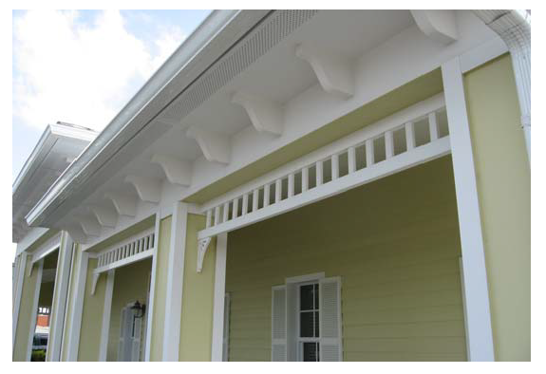~~

~~Porches shall have wood or the appearance of light framed wood columns and railings. Other items such as spandrels and fretwork trim are also required as integral design elements for the porch structure. Vinyl or metal elements are acceptable provided that these materials are appropriately scaled to give the appearance of a wood structure. Exposed lookout beams shall also have suitable finishes compatible with the porch and other building elements.~~

~~Railings and balustrades shall have the appearance of wood pickets or ornamental turned or sawn posts and be secured to vertical support columns made from suitable materials such as wood, metal or other structural materials. The design, ornamentation and finish color of the railing shall be sympathetic to the overall design of the structure. All porch and balcony railings and balusters must meet all City of Newberry building code requirements. Lattice as a railing element is not acceptable.~~

**[REMAINDER OF THIS PAGE INTENTIONALLY LEFT BLANK]**

~~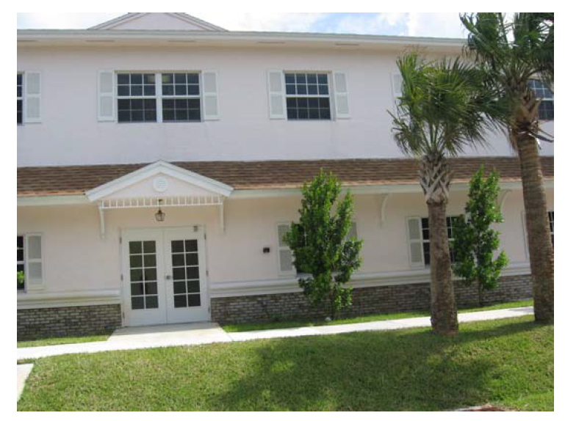~~

~~Trim is an integral element to porch design and is required for all porch facades. The trim shall have the appearance of decorative wood elements and shall be secured to the support beams and/or columns. Trim shall be constructed from wood, metal or other suitable materials. The design and finish color shall be sympathetic to the overall design of the structure. Decorative trim work shall have a color that differs from the main color of the structure.~~

~~6.~~ *~~Signs.~~* ~~Signs shall be sympathetic to the overall design of the main building. Background materials shall be historic north Florida palates. The frame shall match the exterior building color. Monolithic sign supports shall be similar in size, scale, mass and character of the exterior building elements.~~

~~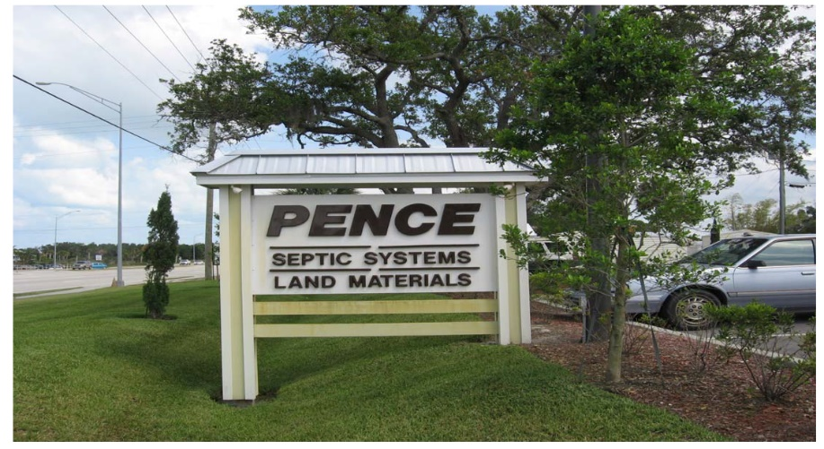~~

~~a. Routed wood signs are acceptable and should be similar to the building colors and materials.~~

~~b. The sign font shall be sympathetic to the overall building design.~~

~~c. Gingerbread trim, metal ironwork and decorative finishes are acceptable design elements and are encouraged.~~

~~d. Lighting of signs shall be incandescent, unless encapsulated by a frame and plastic light box panels. Except as provided elsewhere in these regulations to allow electronic message signs, neon, animated and strobe lighting are not acceptable.~~

~~e. Landscaping is required around the base of all freestanding signs.~~

~~f. Handicap and safety/warning signs are exempt from these requirements.~~

~~g. Traffic and safety control-related signs are exempt from these requirements.~~

~~h. All signs must meet the City of Newberry Sign Code requirements.~~

~~7.~~ *~~Best practices—Exterior lighting.~~* ~~The city recognizes the need for adequate lighting for safety, security and informational purposes (signs). The following practices should be followed in all new lighting systems for structures built on commercially zoned lots in Newberry.~~

~~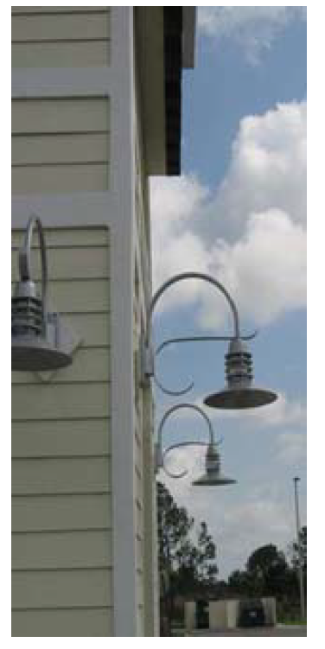~~

~~a. Parking lots shall be illuminated with sufficient lighting for security, and the lumens shall fall to zero at the property line.~~

~~b. Exterior lighting should be of glare-resistant lenses. Lighting should be recessed into a lighting case, cabinet or soffit wherever possible.~~

~~c. The use of MV (mercury vapor), HPS (high pressure sodium), LPS (low pressure sodium), or SOX (Sodium oxide) lighting is discouraged for parking lot and building illumination.~~

~~d. Neon and strip LCD lighting are not acceptable for buildings or sign accents.~~

~~e. Strobing, UV (ultraviolet) or animated lights are prohibited, except as provided elsewhere in these regulations to allow electronic message signs.~~

~~f. Laser lighting or animation, and similar effects are discouraged, except as provided elsewhere in these regulations to allow electronic message signs.~~

~~g. Landscape lighting is acceptable and encouraged. All lights in this category should be shielded so as to not cause undue glare for adjacent vehicular or pedestrian traffic.~~

~~h. Light fixtures and cabinets shall complement the building architecture.~~

~~i. The use of solar, QL (quartz light), white LED and other energy efficient lighting systems is encouraged.~~

~~8.~~ *~~Best practices—Massing and relief.~~* ~~All buildings should have elements to relieve the sense of a solid monolithic mass that complement the scale of surrounding structures and the proposed building. Areas of continuous linear run along a main facade shall have a minimum 16-inch break every 100 feet. Items such as pilasters, colonnades, angle changes and material changes are suitable methods for obtaining relieve in large buildings.~~

~~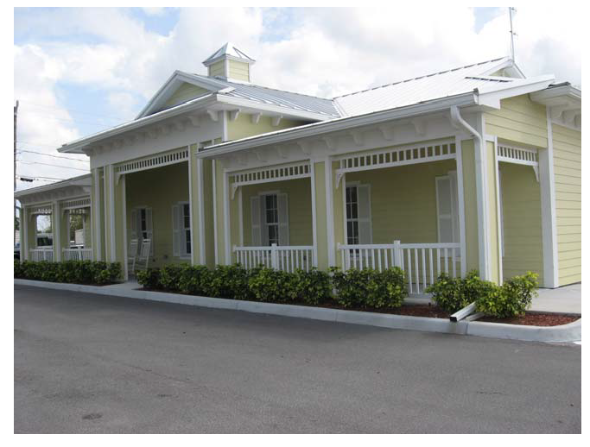~~

* * *

**Section 4.10. CN Commercial, Neighborhood.**

4.10.1. *Districts and intent.* The CN Commercial, Neighborhood category includes one zone district: CN. It is the intent of this district to provide for small scale retail and service developments which serve the convenience needs of a limited population and/or geographic area (i.e., a neighborhood). In accordance with the Comprehensive Plan, this district is not intended to accommodate major or large scale commercial or service activities. The CN district is intended to be oriented to and compatible with the neighborhood to be served, and shall be located on a collector or arterial road.

* * *

4.10.4. *Prohibited uses and structures.*

1. Any use or structure not specifically, provisionally, or by reasonable implication permitted herein.

2. Residential uses, except as specified under CN accessory uses.

3. Off-site signs.

4. Large-scale retail establishments.

* * *

**Section 4.11. Commercial, Highway (CH).**

4.11.1. *Districts and intent.* The "CH" Commercial, Highway category includes one zone district: CH. This district is intended for limited highway oriented retail commercial, office and service activities which serve a market area larger than a neighborhood and shall be located within or within a one-mile radius of a community potable water system or a centralized sanitary sewer system service area. While some of the same types of uses are found in CN and CG areas, the BH areas are generally limited in scale and intensity to serve the retail and service needs of commuters. Businesses in this category require locations convenient to automotive traffic and ample off-street parking is required.

* * *

4.11.5. *Special exceptions.* (See also articles 12 and 13.)

1. Open-air restaurant (see section 4.2.35).

2. Recreational vehicle parks and commercial campgrounds.

3. Large-scale retail establishments.

* * *

**Section 4.12. CG Commercial, General.**

4.12.1. *Districts and intent.* The "CG" Commercial, General category includes one zone district: CG. This district is intended for general retail commercial, office and service activities which serve a market area larger than a neighborhood and which are located within a community potable water and centralized sanitary sewer system service area. While some of the same types of uses are found in CN areas, the CG areas are generally greater in scale and intensity. Businesses in this category require locations convenient to automotive traffic and ample off-street parking is required, however; pedestrian traffic may also be found in this district. This district is not suitable for highly automotive-oriented uses.

* * *

4.12.5. *Special exceptions.* (See also articles 12 and 13.)

1. Open-air restaurant (see section 4.2.35).

2. Large-scale retail establishments.

* * *

**Section 4.13. C-CBD Commercial, Central Business District.**

4.13.1. *Districts and intent.* The "C-CBD" Commercial, Central Business District category includes one zone district: C-CBD. It is the intent that this district be applied only to that area which forms the city's center for financial, commercial, governmental, professional, cultural, and associated activities. The intent of this district is to encourage the development of the central business district as a focal point for the community which provides the services for people to live, work, and shop. The regulations in this section are designed to: (1) protect and enhance the district's suitability for activities which need a central location; (2) discourage uses which do not require a central location; and (3) discourage uses which may create friction with pedestrian traffic and the primary activities for which the district is intended. Heavily automotive-oriented uses are, as a rule, prohibited.

* * *

4.13.4. *Prohibited uses and structures.*

1. Manufacturing, except goods for sale at retail on the premises.

2. Warehousing and storage except as accessory to be permitted principal use.

3. Sales, service, or storage of goods except in completely enclosed buildings.

4. Retail commercial outlets for sale of new and used automobiles, motorcycles, trucks and tractors, mobile homes, boats, heavy machinery and equipment, lumber and building supplies, and ~~monuments~~large-scale retail establishments.

5. Off-site signs.

6. Any other uses or structures not specifically, provisionally, or by reasonable implication permitted herein.

* * *

**Section 4.14. - CI Commercial, Intensive.**

4.14.1. *Districts and intent.* The "CI" Commercial, Intensive category includes one zone district: CI. This district is intended for intensive, highly automotive-oriented uses that require a conspicuous and accessible location convenient to streets carrying large volumes of traffic. Such activities generally require large land areas, do not cater directly in appreciable degree to pedestrians, and require ample off-street parking and off-street loading space. This district permits certain uses not of a neighborhood or general commercial type and serves the entire city.

* * *

4.14.5. *Special exceptions.* (See also [articles 12](https://library.municode.com/fl/newberry/codes/code_of_ordinances?nodeId=PTIICOOR_APXBLADERE_ART12APSPEXVAIN) and 13.)

1. Package store for sale of alcoholic beverages, bar, tavern or cocktail lounge.

2. Off-site signs (see also [section 4.2](https://library.municode.com/fl/newberry/codes/code_of_ordinances?nodeId=PTIICOOR_APXBLADERE_ART4ZORE_S4.2SUDIRE)).

3. Automotive service stations (see [section 4.2](https://library.municode.com/fl/newberry/codes/code_of_ordinances?nodeId=PTIICOOR_APXBLADERE_ART4ZORE_S4.2SUDIRE) for special design standards for automotive service stations).

4. Service establishments such as crematory.

5. Commercial tourist attractions.

6. Open-air restaurants (see section 4.2.35).

7. Recreational vehicle parks and commercial campgrounds.

8. Large-scale retail establishments.

* * *

**Section 4.15. Commercial, Automotive (CA).**

4.15.1 *Districts and intent.* The "CA" Commercial, Automotive category includes one zone district: CA. This district is intended specifically for intensive retail sales and service uses and is automotive-oriented which requires a conspicuous and accessible location convenient to streets carrying large volumes of traffic. Such activities generally require large land areas, do not cater directly in appreciable degree to pedestrians, and require ample off-street parking and off-street loading space. This district permits specific automotive-oriented uses, which are not permitted within the other commercial districts and this district serves the entire city.

* * *

4.15.5. *Special exceptions.* (See also articles 12 and 13.)

1. Open-air restaurants (see section 4.2.35).

2. Recreational vehicle parks and commercial campgrounds.

3. Large-scale retail establishments.

* * *

Sec. 4.22. Overlay districts.

4.22.1 *Purpose and intent.* Lands in the city may be classified into one of the base zone districts in ~~s~~Sections 4.3 through ~~section~~ 4.21 of the Land Development Regulations, and one of the overlay districts set forth in this section. Where land is classified into an overlay district and a base zone district, the regulations governing development in the overlay district and the base zone district shall apply. In the event of a conflict between the standards governing a base zone district and an overlay district, the standards governing the overlay district shall control.

4.22.2 *District~~s~~.*

(A) *State Road 26 and US Highway 27/41 Gateway Overlay District.*

(1) *General purposes.* In recognition of the importance of promoting the city as an attractive, vibrant, and economically prosperous community, and in keeping with the city's rural, small-town character, the city hereby creates the State Road 26 and US Highway 27/41 (SR 26 and US 27/41) Gateway Overlay District which is included in the Official Zoning Atlas of the City of Newberry and incorporated herein by reference, for the purpose of:

(a) Welcoming existing and future residents and visitors to the city;

(b) Promoting Newberry as an attractive, vibrant, and economically prosperous community;

(c) Establishing consistent and harmonious design standards in order to unify the visual quality of the Gateway Overlay District;

(d) Creating enhanced visual gateways to areas that serve as the main entrances to the city;

(e) Improving the sense of place and community;

(f) Creating a positive impression of the city, reflecting community values, including the city's rural, small-town character;

(g) Maintaining and enhancing property values; and

(h) Protecting the public health, safety, and welfare.

(2) *Applicability.*

(a) The standards of this section shall apply to all lands that lie within the Gateway Overlay District.

(b) The Gateway Overlay District consists of parcels, or portions thereof, within 500 feet of the SR 26 and US 27/41 rights-of- way and are located within the City of Newberry municipal limits as measured by perpendicular line from the ultimate right(s)-of-way line.

(c) The standards of this section shall apply to only the portion of the parcel located within the Gateway Overlay District.

(d) All proposed uses on property located within the Gateway Overlay District shall comply with all the requirements of this section.

(e) For regulations not addressed in this section, the relevant Land Development Regulations section(s) shall govern.

(f) All proposed uses on property located within the Gateway Overlay District shall be subject to the development standards set forth in the underlying zoning district, unless a more restrictive standard is established in this section.

(g) Existing legally approved development on property located within the Gateway Overlay District that does not meet the standards outlined in this overlay district shall be considered a legal nonconformity subject to the nonconformity requirements set forth in article 2, section 2.3.

(3) *Exemptions*.

~~(a) Properties with a zoning designation of Planned Unit Development (PUD) or Planned Development (PD) as of the effective date of these regulations (June 27, 29022) shall be exempt from section 4.22.2(A) in its entirety.~~

(~~b~~a) Properties located within the historic district.

~~(c)~~ ~~Industrial uses adjacent to and utilizing railroad for freight delivery.~~

(~~d~~b) ~~Upon written application, the LDR administrator~~A waiver may be granted ~~exemptions from~~for portions or all of ~~s~~Section 4.22.2(A) for parcels or portions of a parcel that would otherwise be included in the Gateway Overlay District, based on one or more of the following findings:

(i) ~~Due to site topography, the development of the property or portion of the property to be exempted will not be substantially visible from SR 26 and US 27/41~~An application possesses exceptional design, as determined by the Board of Adjustment, that would, in whole or in part, otherwise be prohibited or constrained by these design standards; or

(ii) The property is proposed to be developed with a residential, passive recreation, or agricultural related use located on an individual parcel that is not part of a subdivision permitted after the effective date of these regulations~~.~~; or

(iii) Unique lot configuration not due to actions of the owner, entities or persons, or an immediate heir, successor, or assign of the owner, would otherwise cause the application of these regulations to cause undue burden. Burden of proof to demonstrate and justify hardship shall accompany the relevant application for development permit.

(c) Minor changes and deviations which do not significantly alter the location or design of buildings, stormwater facilities, parking lots, roadway buffers, or otherwise alter an approved site plan and building design below the standards of this Section may be authorized by the City Manager or their designee.

(4) *Prohibited and special exception uses including exterior finishes.*

(a) Permitted and special exception uses allowed in the underlying zoning designation shall be allowed in the SR 26 and US 27/41 Gateway Overlay District, unless modified by the Overlay District standards of this section. The following uses shall be prohibited within the SR 26 and US 27/41 Gateway Overlay District:

(i) Automobile body shop.

(ii) Commercial parking lot or parking structure as a principal use.

(iii) Machine shop.

(iv) Outdoor kennel.

(v) Recycling drop-off center.

(vi) Sexually oriented businesses.

(vii) Ancillary outdoor storage.

(viii) Motor, mobile, and manufactured home sales and leases.

(b) The following uses shall be special exceptions within the SR 26 and US 27/41 Gateway Overlay District:

(i) Automobile sales.

(ii) Recreational vehicle, boat, or ATV sales.

(c) Corrugated metal panels as a primary exterior finish is discouraged unless approval is granted by the Board of Adjustment.

(5) *Development standards.*

These development standards ensure efficient use of land, quality of construction, and maintain the small-town character of the City. The below Table 1 provides required design standards and Table 2 provides additional required standards which only (1) from each category must be implemented in the design of the building and/or site. These standards also address large-scale retail establishments through standards for building location, orientation, massing, and providing direction on architectural elements of buildings.

(a) *Building and site* *design ~~and orientation~~standards.*

~~(i)~~ ~~Architectural elevation plans or renderings, drawn to scale, shall be required for all site plan applications involving exterior renovation or new construction.~~

~~(ii)~~ ~~Except for roofs, metal as a primary finish building material may be approved by the city commission.~~

~~(iii)~~ ~~When two or more buildings are proposed on a single lot of record, the primary building shall be oriented to face the primary public right-of-way, as determined by the LDR administrator.~~

~~(iv)~~ ~~All accessory structures shall be of comparable design and building materials to the principal structure.~~

~~(v)~~ ~~Commercial building facades visible from SR 26 or US 27/41 shall have glazing that constitutes a minimum of 35 percent of the ground floor area between three feet and eight feet above finished floor. There is no maximum limit on how much glazing may be provided. The LDR administrator may grant approval of an alternate compliance to the minimum glazing requirement based on a demonstrated hardship.~~

~~(vi)~~ ~~Front and any other façade visible from SR 26 or US 27/41 shall incorporate no fewer than three architectural elements, which may include, but are not limited to:~~

~~a.~~ ~~Accent materials;~~

~~b.~~ ~~Architectural details, such as tile work and molding integrated into the building facade;~~

~~c.~~ ~~Recesses and/or projections;~~

~~d.~~ ~~Roof overhang, which shall vary according to building width, as follows: one-foot overhang for buildings less than 50 feet in width, two-foot overhang for buildings 50 to 100 feet in width, and three-foot overhang for buildings greater than 100 feet in width;~~

~~e.~~ ~~Varied roof lines;~~

~~f.~~ ~~Articulated cornice lines;~~

~~g.~~ ~~Canopies, awnings, and/or porticos;~~

~~h.~~ ~~Use of brick in at least 30 percent of the facade;~~

~~i.~~ ~~Window shutters;~~

~~j.~~ ~~Changes in building materials;~~

~~k.~~ ~~Prominent public entrances defined by substantive architectural features; and/or~~

~~l.~~ ~~Fountain(s) or other water feature(s).~~

Table 1: Requirements for building and site design.

|  |  |
| --- | --- |
| **Building and Site Design Requirements** | |
| Building Location and Orientation | When two or more buildings are proposed on a single lot of record, the largest building shall be located furthest from the roadway buffers. |
| Buildings closest to the roadway buffer shall be oriented so the main entrance(s) is parallel to and facing the SR26 and US27/41 rights-of-way. |
| Buildings with drive-through service shall locate drive-through lanes and drive-through windows to be perpendicular to the roadway buffers. |
| No more than two parking aisles or rows may be located between the closest building to the roadway buffers or as otherwise determined appropriate by the City Manager or designee. |
| Parking Lots | Off-street parking areas must have a pedestrian pathway aligned with the main entrance connecting the parking areas to the main entrance of the largest single-tenant. In the case of multitenant in-line plazas with generally equal tenant bays, the pedestrian pathway shall be centered to the building. |
| Provide recesses and/or protrusions not less than 8 inches in depth spaced not greater than 35 feet apart from each other or the end of the façade. |
| Wall >50 Feet Long | Stucco walls shall utilize scoring patterns not less than 3/4-inch depth and the pattern shall be compatible with the overall architectural style of the building or bay façade. |
| Provide not less than three (3) unique materials, such as stone, wood, and glass, to emphasize the main entrance of single-tenant buildings. Stucco and masonry blocks shall not count as unique materials for the purposes of satisfying this requirement. |
| Parapets shall not extend more than 5 feet above the roof line. |
| Roofs | Metal roofs must be standing seam. |
| Weeping or drainage holes shall only be located along the service side of a building but are generally discouraged as a method of drainage. |
| All rooftop mechanical equipment must be screened by an opaque wall or louvered paneling at height not less than 1 foot above the highest elevation of the mechanical equipment. |
| Rooftop access ladders must be located on the service side of the building and secured by a lock or other mechanism to prevent access by the general public. |
| All roof downspouts shall be incorporated or enclosed to be indistinguishable from the front the façade or shall be located along the service side of the building. |
| Main entrances shall be recessed or shall provide an overhead shade structure or any combination thereof extending not less than 6 feet in depth as measured along a projecting perpendicular line from the plane of the exterior entrance door. |
| Building Entrances | Multi-tenant buildings shall provide overhangs, canopies, arcades, or other means of shading walkways in front of multitenant buildings. |
| To the greatest extent possible, wall signs shall be located over the main entrance. |
| Window locations and design shall be consistent and compatible with the overall architectural theme or style of the building or individual bay. |
| Windows | Large-scale retail establishments shall incorporate more than one (1) geometric shape not less than 15% of the overall interior cubic area of the building. Other required and optional improvements, such as arcades, protrusions and recesses, and recessed entrances shall not be count towards satisfying this requirement. Refer to Diagram 1 below. |
| Building Massing/Shapes | For multi-story buildings, between the ground floor and the stories above, a unique material or architectural element, such as decorative brickwork and protrusions, shall be utilized to show the separation from the ground floor. Stucco scoring shall not count towards a unique material or architectural element to satisfy this requirement. |
| Not less than 25% of the outdoor dining area shall be shaded by a permanent shade structure mounted to the ground or the building. |
| Outdoor Dining Areas | Channel letters must be individually mounted. |
| Wall Signs | Box signs must be tiered unless otherwise determined acceptable to the City Manager or designee. |
|  |

**[REMAINDER OF THIS PAGE INTENTIONALLY LEFT BLANK]**

Diagram 1: Building massing/shapes.

Table 2: Options for building as site design.

|  |  |
| --- | --- |
| **Building and Site Design Options (Must Implement One (1) From Each Applicable Category)** | |
| Building Location | Outparcels or secondary buildings shall be located along interior roads except multitenant buildings containing more than 6 bays, suites, or units may be located closest to and oriented towards the SR26 & US27/41 rights-of-way. |
| Buildings and parking areas shall be located on the highest naturally occurring topographical areas and stormwater management facilities on the lowest naturally occurring topographical areas. |
| Parking Lots | Provide a clearly delineated centralized accessible pathway from the furthest parking or drive aisle to the main entrance. |
| Provide an internal multi-use (pedestrian, bicycle, or golf cart) pathway connecting all businesses within the site as determined acceptable by the City Manager or designee. |
| Utilize low infiltration drainage systems throughout the vehicular use areas/parking lot. |
| Locate all parking stalls, except accessible parking stalls, on the side and rear of the building(s). |
| Roofs | Provide gutters along roof driplines abutting main entrances. |
| Roof material shall be of a high albedo color, finish, or material |
| Flat or tilt roofs must slope downward towards the service side of the building. |
| Walls >50 feet Length | Provide landscape islands (raised or at grade) along the front and sides of a building spaced not less than 35 feet apart from each other or the end of the façade consistent with the roadway landscape buffers herein below, however, tree species may be a dwarf variety. Landscape islands must be irrigated or planted with draught tolerant species. |
| Provide decorative skirting material for not less than the lowest 3 feet of the building façades except for the service side of the building. |
| Buildings shall utilize not less than 2 unique materials, such as stone, wood, and glass, in a manner compatible with the overall architectural style as determined acceptable by the City Manager or their designee. Stucco shall not count as a unique material for the purposes of satisfying this requirement. |
| Building Entrances | Utilize unique façade designs and materials for each bay on a multitenant building beginning and ending at the centerline of the interior separation wall. |
| Provide decorative gables over main entrance(s). |
| Provide a landscape buffer consistent with Zone 1 herein below along both sides of the primary access driveway to the first point of intersection with another interior access driveway. |
| Windows | Not less than 35% glazing of the ground floor façade facing the SR26 and/or US27/41 rights-of-way. |
| For multifamily and mixed-use buildings, provide one (1) juliette balcony on a window not less than five (5) feet tall per unit in a manner compatible with the overall architectural style of the building. |
| For multifamily buildings, provide one (1) covered balcony or porch per unit. |
| Utilize decorative window elements, including, but not limited to muntins, shutters, or arches. |
| Provide transom windows along the north facade of a building in lieu of full-sized windows. |
| Multi-Story Buildings | Vary the size and shape windows of multi-story buildings. |
| Provide eyebrows, protrusions, shade structures, or other method of shading windows acceptable to the City Manager or their designee. |
| Site Amenities | Provide public gathering place, such as a park, dog park, square, piazza, or other places meant for public gathering of an area not less than the average gross floor area of the on-site buildings. |
| Provide a water features, such as reflecting pools, fountains, or other water feature adjacent to outdoor dining areas. |
| Outdoor Dining Areas | Shall be separated or delineated by decorative railings consistent with the architectural style of the building. |
| Shall be delineated by decorative and functional surface materials, such as pavers, tiles, decking, or other suitable material. |
| Shall be elevated not less than 6 inches from adjacent pedestrian pathways. |

(b) *Loading and service*.

(i) Loading and service areas, including but not limited to docks, waste collection and storage, drive-throughs, and other functionally similar uses, shall be located to the rear or side of buildings and shall be screened by 100% opaque wall or landscaping. In no instance shall the loading and service area be located between the building and SR 26 or US 27/41, regardless of building orientation.

a. Failure to maintain landscape screening to provide shall constitute a violation of these regulations.

(c) *Fencing.*

(i) Fences ~~erected~~ within SR 26 or US 27/41 roadway buffers ~~required~~allowed per ~~s~~Section 4.22.2(A)(5)(g) are limited to a maximum height of four feet and shall not be ~~built of~~ galvanized or corrugated metal sheets or chain link. ~~This is not intended to prohibit f~~Fences required to screen accessory uses (section 4.22.2(A)(5)(d)) within the roadways buffers may utilize a combination of berm, landscaping, and fencing to achieve~~,~~ specific use screening standards (~~s~~Section 4.22.2(A)(5)(e) and (h))~~, or residential uses (sSection 4.22.2(A)(5)(h)) that may abut the roadway buffer~~.

(d) *Accessory uses.*

(i) All accessory outdoor storage areas will be screened from view from all property lines and adjacent rights-of-way by a landscape earthen berm, or an opaque fence or wall between six feet and eight feet in height. A fence or wall shall incorporate at least one of the predominant materials and one of the predominant colors used in the primary structure. Materials may not be stored higher than the height of the ~~primary structure~~screening. The perimeter of the fence or wall shall be landscaped with a three-foot-wide strip containing a minimum three-foot-high hedge with plantings not more than three feet-on-center.

(ii) Such screening requirements apply to trash collection and the parking of all commercial vehicles ~~used for commercial purposes~~ which may be visible from the SR 26 and/or US 27/41 rights-of-way.

(e) *Specific use standards.*

(i) The following uses shall meet these use-specific standards in addition to applicable standards outlined in section 4.2.

a. *Car wash.* Tunnels shall not be oriented towards the SR 26, US 27/41, or a residential use within 100 feet.

b. *Self-storage.* Storage unit roll-up doors shall not be visible from SR 26 or US 27/41 unless the units are properly screened from view or interior to a building.

c. *Automobile repair shop.* Bay doors shall not be oriented towards or wholly visible from the SR 26, US 27/41, or a residential use within 100 feet. Automobiles being serviced shall be screened from view from all public rights-of-way.

d. *Outdoor display*. Outdoor display of any type of motorized vehicles, boats, storage buildings, or equipment for sale or rental, except for automobile rentals associated with hotels or motels, shall be screened from view from SR 26 or US 27/41.

(f) *Site landscaping requirements.*

(i) ~~Landscape plans, drawn to scale and signed and sealed by a licensed professional, shall be required for all new construction and projects involving renovations, expansions, and/or additions where the work exceeds 50 percent of the structure's gross floor area.~~Preservation of champion trees, as defined by the Florida Department of Agriculture and Consumer Services, shall be required and a landowner shall enter into a Florida Champion Tree Property Owner Agreement, in a form acceptable to the City Attorney which shall be recorded in the Official Records of Alachua County, Florida, prior to the commencement of construction activity, including tree removal, clearing and grubbing, grading, depositing of fill and similar materials, staging of construction equipment and materials, and/or installation of temporary access drives. Champion trees shall be nominated by the City Manager or their designee for entry into the Florida Champion Tree Register maintained by the Florida Department of Agriculture.

(ii) All plant material within the Overlay District shall be native or adapted species and shall meet the following minimum standards:

a. All nursery plants, including trees, shrubs and groundcovers shall conform to standards for Florida Grade #1 or better according to the current, most recent edition of "Grades and Standards for Nursery Plants"~~,~~ published by the Florida Department of Agriculture and Consumer Services, Division of Plant Industry~~,~~ and available from the Florida Nursery, Growers, and Landscape Association (FNGLA).

b. All trees, except those meeting stormwater basin landscaping requirements, shall be a minimum of 30-gallon, two-inch ~~caliper size~~diameter at breast height, at time of installation. Trees meeting stormwater basin landscaping requirements shall be a minimum of seven gallons, ¾" caliper size, at the time of installation. All shrubs and groundcovers shall be a minimum of three-gallon size at time of installation.

(iii) Applicants shall select from the following list of approved trees to create a consistent and uniform planting program for the required landscaping within the Gateway Overlay District. ~~The LDR administrator may approve alternative species on a case-by-case basis.~~

a. Shade trees:

i. *Magnolia grandiflora*, Southern Magnolia;

ii. *Ulmus alata*, Winged Elm;

iii. *Acer rubrum*, Red Maple;

iv. *Betula nigra*, River Birch;

v. *Pinus palustris*, Longleaf Pine;

vi. *Pinus elliottii*, Slash Pine;

vii. *Planus occidentalis*, Sycamore;

viii. *Quercus austrina*, Bluff Oak;

ix. *Quercus geminata*, Sand Live Oak;

x. *Quercus michauxii*, Swamp Chestnut Oak;

xi. *Quercus shumardii,* Shumard Oak;

xii. *Quercus virginiana*, Southern Live Oak; or

xiii. *Taxodium distichum*, Bald Cypress.

b. Ornamental trees:

i. *Cercus canadensis*, Redbud;

ii. *Chionanthus virginicus*, Fringe Tree;

iii. *Ilex cassine*, Dahoon Holly;

iv. *Ilex x attenuata* 'East Palatka', East Palatka Holly;

v. *Ilex x atenuata* 'Savannah', Savannah Holly;

vi. *Ilex x 'Nellie R. Stevens'*, Nellie R. Stevens Holly;

vii. *Lagerstroemia indica,* Crape Myrtle;

viii. *Prunus angustifolia*, Chickasaw Plum;

ix. *Sabal palmetto*, Cabbage Palm; or

x. *Viburnum obovatum*, Walter's Viburnum.

(g) *Roadway buffers.*

(i) Buffering for properties with frontage along SR 26 and/or US 27/41 shall meet the following requirements of this section.

(ii) General provisions:

a. Buffers on residential developments shall be designated as common areas and shall not be included within lots;

b. Buffers on non-residential sites may be included within lots and counted toward building setback requirements;

c. No buildings or parking are permitted in buffers;

d. Sidewalks, above and underground utility infrastructure, drainage facilities, freestanding signs, lighting, screening, and other improvements deemed necessary by the LDR administrator may be in buffers;

e. Buffer areas may include all or portions of the stormwater management system if the applicant demonstrates that the character and intent of the buffer is not diminished;

f. Utility lines may exist in the buffer provided that the buffer's purpose is not compromised or minimized and the specified number of plantings required must be met;

g. Pedestrian access and trails within a buffer may be permitted provided the character and intent of the buffer is not diminished;

h. Existing native trees and vegetation may be used to fulfill roadway buffering and screening requirements where such existing natural vegetation is of sufficient size and opacity to provide an effective buffer. Credit for preservation of existing trees shall be provided in accordance with ~~s~~Section 74-66;

i. All buffers shall be maintained to remove invasive ~~non-native~~exotic trees and vegetation; and

~~j.~~ ~~Alternative screening plans may be evaluated by the LDR administrator and approved at the LDR administrator's discretion.~~

(iii) The landscaped buffer width and minimum quantity of landscape plantings are determined based on the site's location within one of three roadway buffer zones. Zone boundary limits:

Table 3: Defined Roadway Buffer Zones

|  |  |  |  |  |
| --- | --- | --- | --- | --- |
| Zone | North | East | South | West |
| 1 | SR 26/US 27/41 intersection to NW 16th ~~Place~~Avenue | SR 26/US 27/41 intersection to NW 231st Court | SR 26/US 27/41 intersection to SW 15th Avenue | — |
| 2 | NW 16th ~~Place~~Avenue to NW ~~32nd~~46th Avenue | NW 231st Court to NW/SW ~~218th~~202nd Street | SW 15th Avenue to SW ~~30~~46th Avenue | NW/SW 266th Street to West City limits |
| 3 | NW ~~32nd~~46th Avenue to North City limits | NW/SW ~~218th~~202nd Street to East City limits | SW ~~30~~46th Avenue to South City limits | — |

**[REMAINDER OF THIS PAGE INTENTIONALLY LEFT BLANK]**

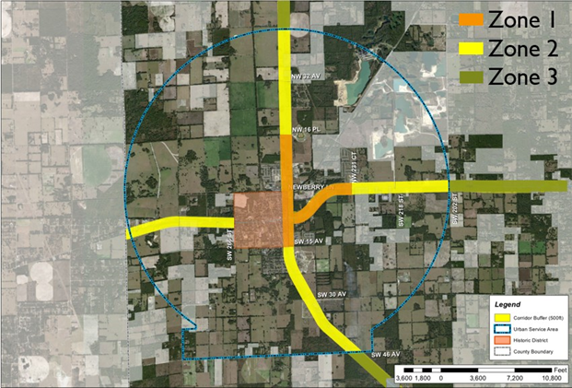

(iv) Trees can be clustered and do not need to be evenly spaced, as long as the distribution is balanced within the buffer corridor. Buffers shall contain a mix of shrubs, ornamental grasses, and groundcovers not to exceed spacing of four feet on center. Bedlines should be natural, organic, and non-linear, where possible. Width of planting areas within the buffer shall be varied, with minimum width not to exceed those shown in Diagram A. Gaps of sod or mulch between landscaped areas shall not exceed 20 feet in width. Driveway widths shall be excluded from the buffer corridor calculation.

(v) Diagram ~~A~~2: Required Buffer Plantings

**[REMAINDER OF THIS PAGE INTENTIONALLY LEFT BLANK]**

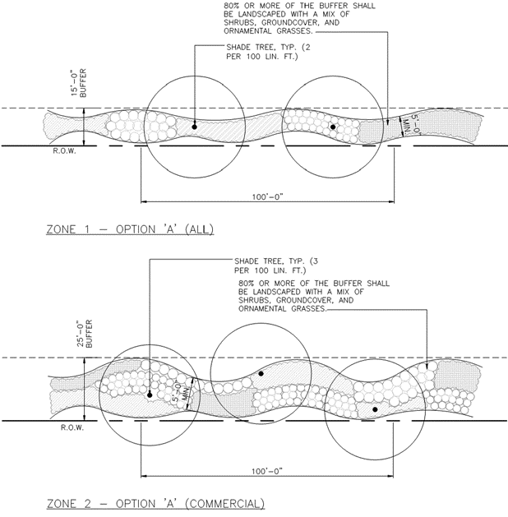

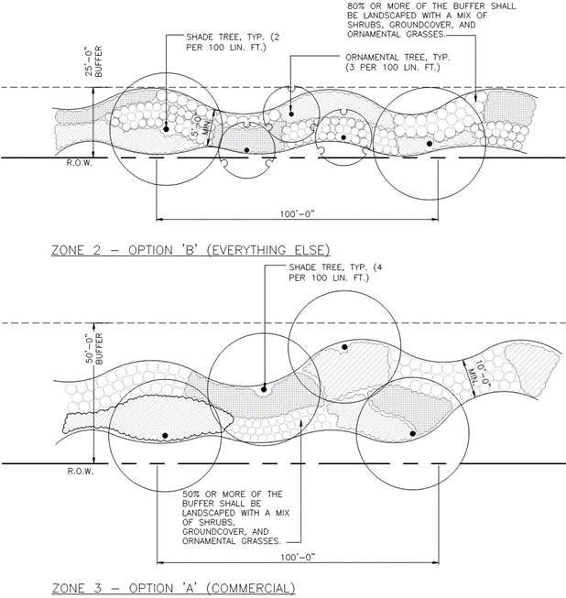

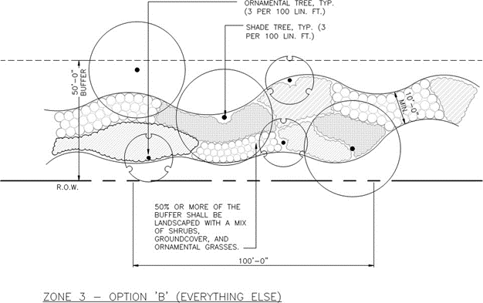

(h) Where the sides or rear of residential lot lines are visible from SR 26 or US 27/41, additional screening is required in accordance with the following:

(i) Option A: A berm of four (4) feet high minimum combined with plantings to achieve a total screen minimum height of six (6) feet at time of planting as measured from the abutting crown of road or grade of adjacent residential property, the greater thereof. Berm slopes ~~should~~shall be a maximum of 3:1. Berms shall be of irregular shape and shall have no parallel sides~~, unless otherwise approved by the LDR administrator~~;

(ii) Option B: A minimum six (6) feet tall opaque fence and decorative masonry columns~~(chain link fencing is not permitted)~~;

(iii) Option C: Landscape plantings including trees, shrubs, groundcovers to achieve a minimum six feet (6~~'~~) height screen, to reach 75-percent opacity in two years;

(iv) Option D: A combination of the above options to achieve a minimum six (6) feet height and ~~75~~100-percent opacity in two (2) years~~; and/or~~.

~~(v)~~ ~~Option E: Alternative screening plans may be evaluated by the LDR administrator and approved at the LDR administrator's discretion.~~

(i) *Landscaping in vehicular use areas.*

(i) Screening shall be provided where a vehicular use area is visible from any adjacent property and/or street right-of-way. The screening shall consist of:

a. A single row of shrubs spaced at a maximum four feet on center, minimum, to provide a visual screen not less than 50 percent opaque upon planting. Shrubs shall be planted in a strip no less than five feet in width and may be planted in the required street buffer;

b. An average of two shade trees for every 100 linear feet, or fraction thereof, of the paved vehicular use area, excluding driveway widths. The distance between such trees shall be planted between 25 to 55 feet apart; and

c. Plant material provided as part of the vehicular use area landscaping parallel to the roadway buffer and within 50 feet of same may count towards buffer requirements.

(ii) One shade tree is required within each landscape island.

(j) *Landscaping in stormwater management facilities.*

(i) When visible from the right-of-way, ~~S~~stormwater ~~M~~management ~~F~~facilities (“SMF”) shall be planted with one native tree per 35 linear feet, or fraction thereof, of basin perimeter. Native shrubs, groundcover, and/or ornamental grass shall be provided to cover 25 percent of the basin slope area. The basin slope area shall be measured from the basin's top closed contour to the basin's lowest closed contour, not including maintenance paths.

(ii) Trees shall be placed no closer than 20 feet from stormwater structures.

(k) *Cross access.* Vehicular and/or multi-modal cross access shall be required, except if prohibited due to utilities or topography.

(l) *Signage.* Except as stated below, signs within the Gateway Overlay District shall comply and be subject to the standards in section 4.2.20.

(i) Under no circumstances shall a sign's illumination mechanism be visible to vehicles, pedestrians, or other modes of transportation. All illumination must be internal or directed upon the sign's face with no direct line of sight to the bulb(s) or lighting fixtures.

(ii) *Prohibited signs.*

a. Billboards.

b. Signs that display video or images.

c. Balloons, streamers, and air- or gas-filled figures, except for promotional purposes for a limited period determined by the city manager or designee.

d. Promotional beacons, searchlights, and/or laser lights/images, except for promotional purposes for a limited period determined by the city manager or designee.

e. Signs that emit audible sounds, smoke, vapor, particles, or odor.

f. Signs on utility poles or trees.

g. Signs or advertising devices attached to any vehicle or trailer to be visible from public right- of-way, including vehicles with for sale signs and excluding vehicles used for daily transportation, deliveries, or parked while business is being conducted on-site.

h. Pylon signs.

(iii) *Freestanding signs.*

a. Freestanding signs, as monument or ground- based podiums, shall be permitted within the Gateway Overlay District.

b. Sign dimensional criteria are based on the roadway speed limit. Sign dimensions shall be computed consistent with LDR 4.2.20.7.

i. Residential subdivision signs:

|  |  |  |  |
| --- | --- | --- | --- |
| Speed Zone | Sign Height | Max Sign Area | Max Sign Area per |
|  | (FT) | (SF) | Side (SF) |
| 31-50 | 6 | 80 | 40 |
| 51-65 | 8 | 160 | 80 |

ii. Non-residential signs:

|  |  |  |  |
| --- | --- | --- | --- |
| Speed Zone | Sign Height | Max Sign Area | Max Sign Area per |
|  | (FT) | (SF) | Side (SF) |
| 31-50 | 8 | 48 | 24 |
| 51-65 | 12 | 120 | 60 |

iii. Multi-tenant signs:

|  |  |  |  |
| --- | --- | --- | --- |
| Speed Zone | Sign Height | Max Sign Area | Max Sign Area per |
|  | (FT) | (SF) | Tenant (SF) |
| 31-50 | 10 | 100 | 10 |
| 51-65  (UNDIVIDED) | 20 | 200 | 20 |
| 51-65  (UNDIVIDED) | 25 | 250 | 25 |

c. A sign and its structural base or body shall be composed of materials identical to or similar in appearance, color, and texture to the materials used for the building to which the sign is accessory or advertising.

d. Changeable copy signs shall only be allowed to comprise up to 50 percent of the total sign area for commercial signs and up to 30 percent of the total sign area for multi-tenant signs.

(iv) *Window signs.*

a. Window signs shall be incorporated into the overall sign area allowed for wall signage as per section 4.2.20.9.c.

b. Signage on any individual window shall not comprise more than 25 percent of the window area.

(v) *Landscaping and buffering.*

a. All freestanding signs shall provide a landscaped area around base of the sign meeting the following standards:

i. Installation of a minimum three-foot-wide landscaped buffer around the base of the sign.

ii. Such buffers must be landscaped with a mixture of ~~shrubs,~~ groundcover~~,~~ and/or other ornamental grasses.

(vi) *Nonconforming signs.*

a. Nonconforming signs shall be subject to the nonconforming standards as established in section 4.2.20.14.

~~(vii)~~ *~~Alternate compliance.~~*

~~a.~~ ~~Signs that do not meet the dimensions requirements outlined in this section may be permitted, if the applicant can demonstrate the sign is part of an overall theme, enhances the development character as a landmark or other character icon, and does not endanger the publics' health, safety, or welfare.~~

**Section 2. Codification and Scrivener’s Errors.** The provisions of this Ordinance shall be cofified as determined to be appropriate by the City Commission of the City of Newberry; and the sections of this Ordinance may be renumbered or re-lettered and the words of this Ordinance may be changed to section, article, or some other appropriate word or phrase to accomoplish codification at the discretion of the City Manager or designee; and, typographical errors and other matters of a similar nature that do no affect the intent of this Ordinance, as determined by the City Clerk or City Attorney, may be corrected with authorization of the City Manager or their designee without the need for a public hearing.

**Section 3. Severability.** If any provision or portion of this ordinance is declared by any court of competent jurisdiction to be void, unconstitutional or unenforceable, then all remaining provisions and portions of this ordinance shall remain in full force and effect.

**Section 4. Conflict.** All ordinances or portions of ordinances in conflict with this ordinance are hereby repealed to the extent of such conflict.

**Section 5. Effective Date.** This ordinance shall become effective upon adoption.

**Section 6. Authority.** This ordinance is adopted pursuant to the authority granted by Section 166.021, Florida Statutes, and Sections 163.3161 through 163.3215, Florida Statutes.

**[REMAINDER OF THIS PAGE INTENTIONALLY LEFT BLANK]**

DONE THE FIRST READING, by the City Commission of the City of Newberry, Florida, at a regular meeting, this ___day of , 202 .

DONE, THE PUBLIC NOTICE, on the website of Alachua County at alachuacounty.us pursuant to Florida Statute 50.0311(3), by the City Clerk of the City of Newberry, Florida on the _____ day of _______________, 2022 through the ______ day of________________, 2025.

DONE THE SECOND READING, AND ADOPTED ON FINAL PASSAGE, by an affirmative vote of a majority of a quorum present of the City Commission of the City of Newberry, Florida, at a regular meeting, this ___day of , 2025..

BY THE MAYOR OF THE CITY OF NEWBERRY, FLORIDA

_____________________________

Honorable Jordan Marlowe, Mayor

ATTEST, BY THE CLERK OF THE

CITY COMMISSION OF THE CITY OF

NEWBERRY, FLORIDA:

___________________________

Judy S. Rice, City Clerk

APPROVED AS TO FORM AND

LEGALITY:

____________________________

City Attorney’s Office