ORDINANCE NO. 2025-68
LDR 25-29

AN ORDINANCE OF THE CITY OF NEWBERRY, FLORIDA, AN ORDINANCE OF THE CITY OF NEWBERRY, FLORIDA, RELATING TO THE REZONING OF 165.88 CONTIGUOUS ACRES AMENDING THE OFFICIAL ZONING ATLAS OF THE CITY OF NEWBERRY LAND DEVELOPMENT REGULATIONS; PROVIDING FOR REZONING FROM AGRICULTURAL (A) ZONING DISTRICT TO THE AGRICULTURE TECHNOLOGY (AT) ZONING DISTRICT ON PARCEL ID 01919-000-000 ON CERTAIN LANDS WITHIN THE CORPORATE LIMITS OF THE CITY OF NEWBERRY, FLORIDA MORE PARTICULARLY DESCRIBED IN EXHIBIT A; PROVIDING SEVERABILITY; REPEALING ALL ORDINANCES IN CONFLICT; AND PROVIDING AN EFFECTIVE DATE.
WHEREAS, Section 166.021, Florida Statutes, as amended, empowers the City Commission of the City of Newberry, Florida, hereinafter referred to as the City Commission, to prepare, adopt and enforce land development regulations;
WHEREAS, Sections 163.3161 through 163.3215, Florida Statutes, as amended, the Local Government Comprehensive Planning and Land Development Regulation Act, requires the City Commission to prepare and adopt regulations concerning the use of land and water to implement the City of Newberry Comprehensive Plan, hereinafter referred to as the Comprehensive Plan;
WHEREAS, one of the City’s most important economic priorities from the City’s 2022 Strategic Plan is the Agriculture Technology Park;
WHEREAS, the process to get to this point has been many years in the making;
WHEREAS, in 2018 this parcel was formally assigned the Corporate Park Future Land Use classification, and the Official Future Land Use Map of the City was edited.
WHEREAS, on June 23, 2025 the City Commission approved the Agriculture Technology (AT) zoning district (Ordinance 2025-10/LDR 25-09).
WHEREAS, this is a City initiated rezoning, LDR 25-29, for a Site-Specific Amendment to the Official Zoning Atlas (“rezoning”), as described below. A property ownership affidavit was submitted to the Community Development Department and has been processed by the City;
WHEREAS, the determination of available and necessary infrastructure capacity to support the unknown specific levels of development will be dependent upon subsequent development permit applications and supporting impact studies provided by and at the expense of the owner or applicant;
WHEREAS, adoption of this ordinance neither creates entitlements for future unknown levels of development nor obligates the City to approve development permits;
WHEREAS; the change in zoning district of the property does not obligate the City to provide at its expense municipal services to the property and does not guarantee the availability of municipal services to the property;
WHEREAS, the Planning and Zoning Board of the City of Newberry, Florida, hereinafter referred to as the Planning and Zoning Board, has been designated as the Local Planning Agency of the City of Newberry, hereinafter referred to as the Local Planning Agency;
WHEREAS, pursuant to Section 163.3174, Florida Statutes, as amended, and the Land Development Regulations, as amended, the Planning and Zoning Board, serving also as the Local Planning Agency, held the required public hearing, with public notice. At said public hearing, the Planning and Zoning Board, serving also as the Local Planning Agency, reviewed and considered all comments received during said public hearing. as described below, and recommended to the City Commission approval of said city-initiated rezoning for an amendment, as described below;
WHEREAS, pursuant to Section 166.041, Florida Statutes, as amended, the City Commission held the required public hearings, with public notice having been provided on said amendment, as described below, and at said public hearings, the City Commission reviewed and considered all comments received during said public hearing, including the recommendation of the Planning and Zoning Board, serving also as the Local Planning Agency concerning said city-initiated rezoning for an amendment, as described below;
WHEREAS, the City Commission has determined and found said city-initiated rezoning for the amendment to be consistent with the City’s Comprehensive Plan and City’s Land Development Regulations (“LDRs”); and,
WHEREAS, the City Commission has determined and found that approval of said city-initiated rezoning for an amendment, as described below, would promote the public health, safety, morals, order, comfort, convenience, appearance, prosperity or general welfare of the City of Newberry.
NOW, THEREFORE, BE IT ORDAINED BY THE PEOPLE OF THE CITY OF NEWBERRY, FLORIDA, AS FOLLOWS:
Section 1. Official Zoning Map Amended. Pursuant to the City initiated rezoning, LDR 25-29 request, to amend the Official Zoning Atlas of the City of Newberry Land Development Regulations on lands herein more particularly in Exhibit A consisting of 165.88 acres is HEREBY CHANGED FROM AGRICULTURAL (A) to AGRICULTURE TECHNOLOGY (AT).
Section 2. Severability. If any provision or portion of this Ordinance is declared by any court of competent jurisdiction to be void, unconstitutional or unenforceable, then all remaining provisions and portions of this ordinance shall remain in full force and effect.
Section 3. Scrivener’s Error. The correction of typographical errors which do not affect the intent of the ordinance may be authorized by the City Manager or designee without public hearing, by filing a corrected or re-codified copy of the same with the City.
Section 4. Conflict. All ordinances or parts of ordinances in conflict herewith are hereby repealed to the extent of such conflict.
Section 5. Effective Date. This Ordinance shall be adopted upon the date provided below, as passed.
Section 6. Authority. This Ordinance is adopted pursuant to the authority granted by Section 166.021, Florida Statutes, as amended, and Sections 163.3161 through 163.3215, Florida Statutes, as amended.
DONE THE FIRST READING, by the City Commission of the City of Newberry, Florida, at a regular meeting, this 8th day of September, 2025.
DONE, THE PUBLIC NOTICE, on the website of Alachua County at alachuacounty.us pursuant to Florida Statute 50.0311(3), by the City Clerk of the City of Newberry, Florida on the 11th day of August, 2025.
[REMAINDER OF THIS PAGE INTENTIONALLY LEFT BLANK]
DONE THE SECOND READING, AND ADOPTED ON FINAL PASSAGE, by an affirmative vote of a majority of a quorum present of the City Commission of the City of Newberry, Florida, at a regular meeting, this 22nd day of September, 2025.

BY THE MAYOR OF THE CITY OF NEWBERRY, FLORIDA
________________________________
Honorable Timothy R. Marden, Mayor

ATTEST, BY THE CLERK OF THE
CITY COMMISSION OF THE CITY OF
NEWBERRY, FLORIDA:

___________________________
Judy S. Rice, City Clerk

APPROVED AS TO FORM AND
LEGALITY:

____________________________
City Attorney’s Office

Attachments (#): Exhibit A – Legal Description
Exhibit B – Property Ownership Affidavit

EXHIBIT A
Legal Description

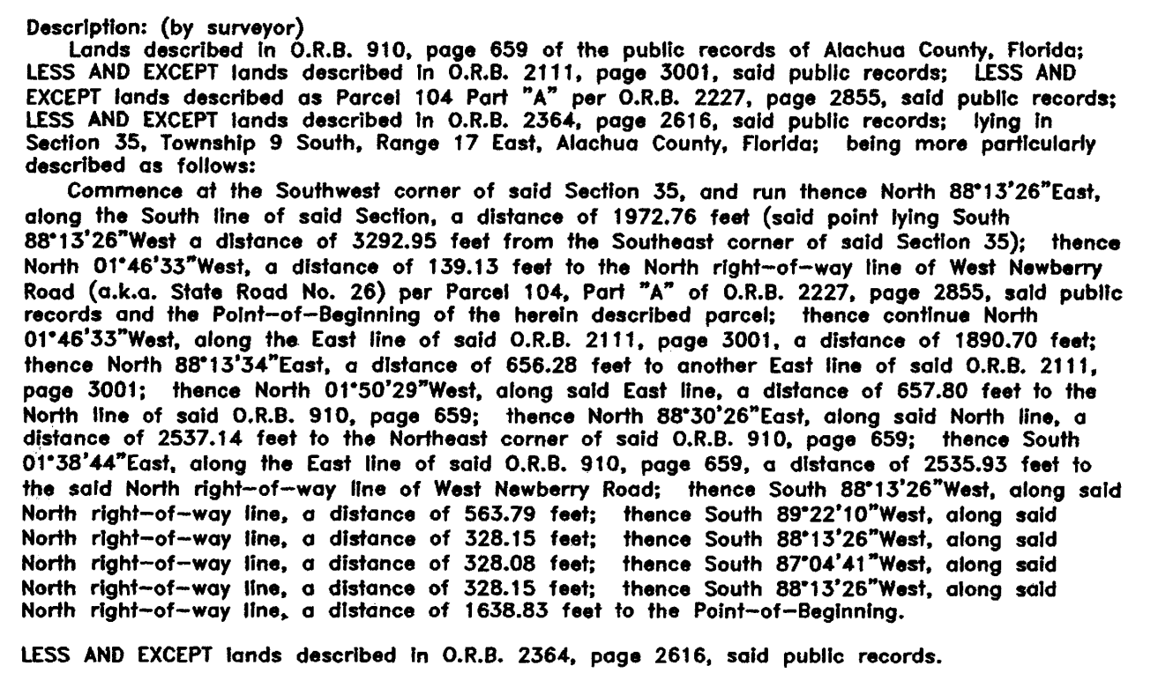

EXHIBIT B
Property Ownership Affidavit

